**Name:Vasavi S Puranik**

**USN:1BM24CS320**

**Batch:K2**

**Insurance database.**

**1.PERSON (driver_id: String, name: String, address: String)**

**CAR (reg_num: String, model: String, year: int)**

**ACCIDENT (report_num: int, accident_date: date, location: String)**

**OWNS (driver_id: String, reg_num: String)**

**PARTICIPATED (driver_id: String,reg_num: String, report_num: int, damage_amount: int)**

**Create the above tables by properly specifying the primary keys and the foreign**

**keys.**

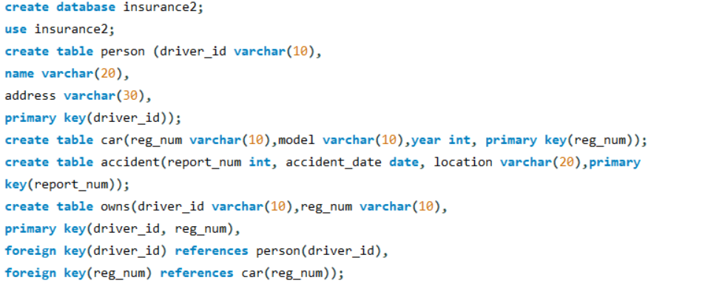

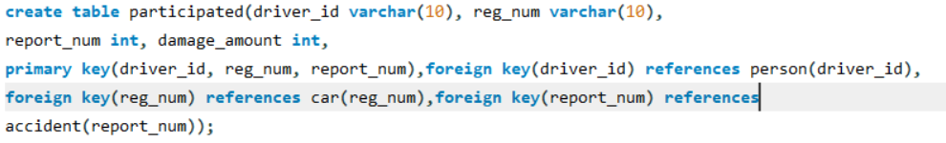

**2.Enter at least five tuples for each relation.**

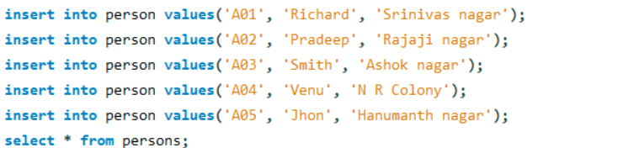

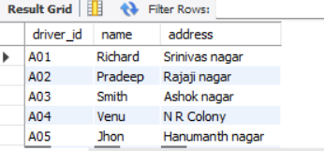

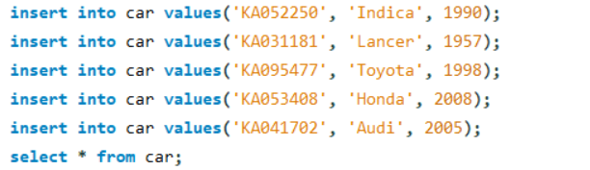

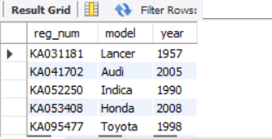

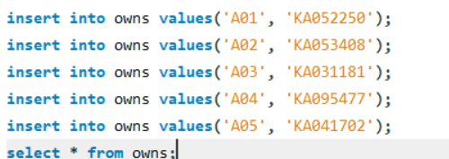

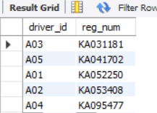

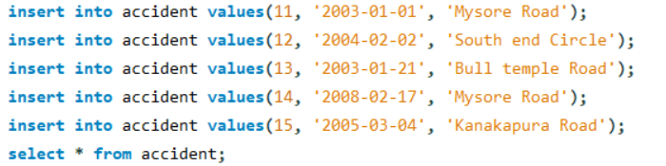

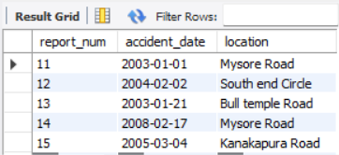

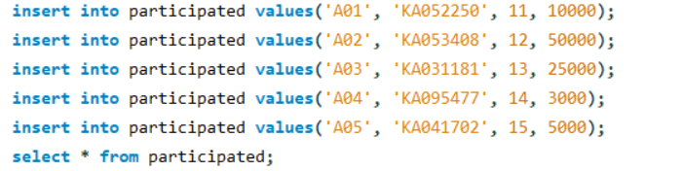

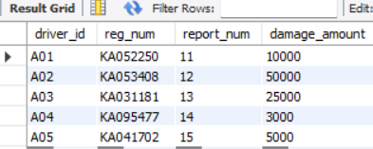

**3. Show all accidents (date and location)**





**4. Find drivers who caused damage ≥ 25000**



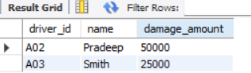

**5. List each driver with the cars they own (one row per ownership)**

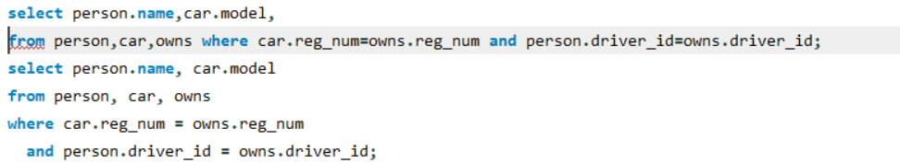

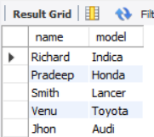

**6. Show accidents and the drivers involved (including damage amount)**

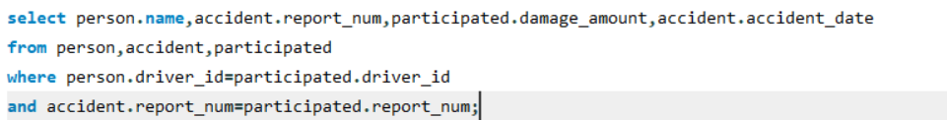

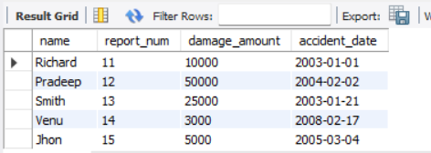

**7. Total damage per accident report**



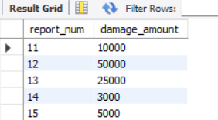

**8. Drivers who were involved in more than one accident**

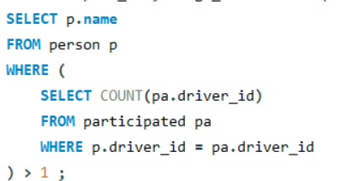



**9. Latest accident (most recent accident_date)**

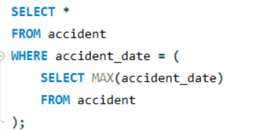

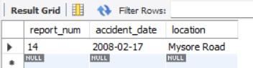

**10. Average damage amount per driver**

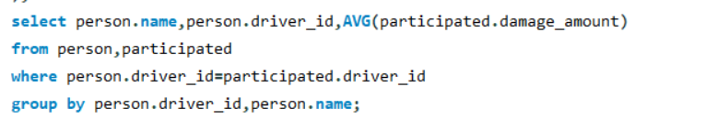

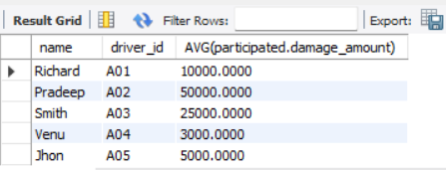

**11. Update: set damage_amount = 25000 for a specific car & report (example)**

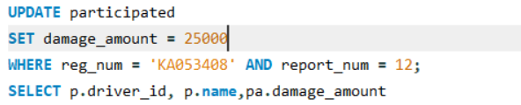

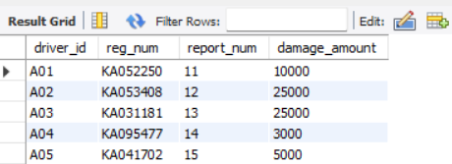

**12. Find drivers who caused the maximum damage in any single accident**



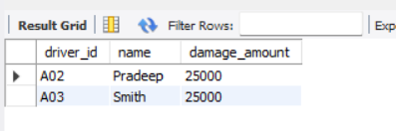

**13. Show cars (model) involved in accidents with total damage > 20000**

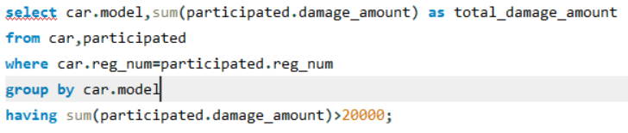

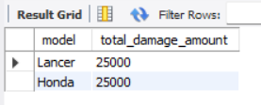

**14. Create a view summarizing accidents with participants count and total damage**



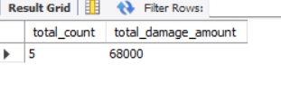

**Additional Queries**

**1.LIST THE ENTIRE PARTICIPATED RELATION IN THE DESCENDING ORDER OF DAMAGE AMOUNT.**

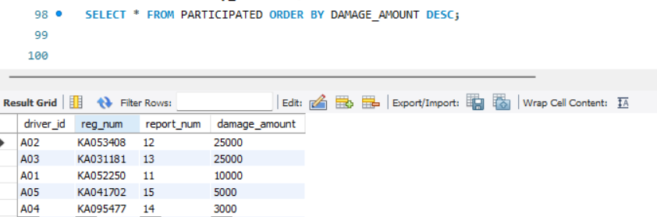

**2.LIST THE NAME OF DRIVERS WHOSE DAMAGE IS GREATER THAN THE AVERAGE DAMAGE AMOUNT.**

